Abstract:

Textbooks play a pivotal role in knowledge dissemination, yet the complexity of their content can pose challenges for readers seeking effective comprehension. This study explores the application of unsupervised topic modeling, specifically Latent Dirichlet Allocation (LDA), as a tool to enhance the understanding of textbook content. LDA, a probabilistic generative model, identifies latent topics within a corpus by uncovering word co-occurrence patterns. Leveraging LDA's ability to extract coherent themes from textual data, this research aims to improve the readability and accessibility of textbook content.

Unsupervised Topic Modeling with Latent Dirichlet Allocation (LDA) for Enhanced Textbook Content Comprehension

Textbooks have long been a cornerstone of education, providing essential knowledge and information to learners across various disciplines. However, the sheer volume of content contained within textbooks can often overwhelm readers, leading to challenges in comprehension and retention. In this study, we explore the application of unsupervised topic modeling, specifically Latent Dirichlet Allocation (LDA), as a novel approach to improve the understanding of textbook content.

Latent Dirichlet Allocation, a widely used probabilistic topic modeling technique, offers a means to automatically identify underlying themes or topics within a corpus of text. By leveraging LDA, this research aims to extract and organize latent topics present in textbook content, thereby facilitating a more structured and intuitive way for readers to grasp the material. The methodology involves preprocessing textual data, training the LDA model on the preprocessed text, and subsequently interpreting and visualizing the generated topics.

Through experimentation on a diverse set of textbooks, we demonstrate the effectiveness of LDA in revealing coherent and meaningful topics. We also introduce a user-friendly interface that presents the extracted topics alongside relevant passages from the textbook, enabling readers to navigate and comprehend the material more efficiently. Additionally, we discuss the potential implications of incorporating LDA-generated topic summaries into educational technology platforms and digital learning environments.

The results indicate that the integration of unsupervised topic modeling, particularly LDA, contributes to a deeper understanding of textbook content by providing readers with a structured overview of key themes. This approach holds promise for enhancing the learning experience, aiding educators in curriculum design, and potentially shaping the future of educational content presentation. As technology continues to transform the educational landscape, the utilization of LDA-driven topic modeling offers a valuable tool for refining textbook content comprehension and knowledge acquisition.

Title: Empowering Education: Unleashing the Potential of Digital Mobile-Based Learning a Qualitative survey

In Bangladesh there is deficiency in English subject as there is shortage of skilled teachers. Simplest solution could be use of technology introduce mobile app based learning. To grasp the English language knowledge from curriculum provided textbook we demonstrate a unique approach unsupervised Topic modeling using textbook corpus. It provides coherent topics, dominant keywords, latent combination of features that characterizes similarities between topics. Our anticipation is through this way student can able to extract meaningful information facilitates students to understand the correlated topics and important keywords related to that topics leads to understand the subtle meaning of the context. To determine it would be inevitable to the course instructor one prototype app is created. In this research scope, qualitative research is undertaken to evaluate the effectiveness of mobile-based digital learning with cutting edge NLP technology on Bangladesh's higher secondary English education. This article presents the key findings and insights from the survey, shedding light on the prospective of digital mobile-based learning in schools for higher secondary English subject with NLP. The purpose of this survey was to explore the challenges, and future potential of integrating mobile devices into the learning process powered by NLP extracted content. In the survey questions, it was indicated whether the students, teachers/instructors, and government organizations would find it acceptable and appreciated if textbook information were made available through a mobile app and presented in interactive format. To demonstrate the mobile app idea during the interrogation survey session a prototype is also prepared. Participants were asked for suggestions on how to make the app better and about any shortcomings. After collecting feedback, word clouds were used to analyze the frequency of the participants' recommended terms, and the LIWC approach was used to estimate overall sentiment. Presumably It provides an insight of teacher’s emotion about inclusion of mobile technology in higher secondary English education system. The survey's findings show that teachers are eager to use new technology in teaching and learning, and there are tremendous opportunities adoption of mobile based digital technology in the context of learning English in Bangladesh.

**Introduction**

In an ever-evolving digital landscape, educational institutions are embracing the power of technology to enhance learning experiences. Mobile technology enables ubiquitous access to educational content, and both students and course instructors can maintain learning materials, assignments and other commitments in organized and easily deliverable manner. Digital mobile-based learning tools offered real-time feedback on students' progress, enabling prompt identification of learning gaps and individualized support. This data-driven approach enhanced the efficacy of formal assessments and ultimately contributed to improved academic outcomes. Digital mobile-based learning facilitated a seamless connection between classroom concepts and real-world applications. By leveraging mobile technologies, teachers could integrate current events and practical examples into lessons, making learning more relevant and relatable to students [20]–[22]. Regular updates, assignment notifications, and progress reports allowed parents to actively participate in their child's learning journey, fostering a stronger teacher-parent-student partnership.

In Bangladesh there is lacking in effective acquisition, synthesis of English language. Lots of students especially students from rural areas fail in English in the national board examinations (such as: PSC, SSC, HSC) [1]–[4]. Our anticipation is rural students are not getting proper education, lacking of learning resources like coaching, private tuition etc and quality of education is low. With recent developments in mobile technology in the field of English language learning [5]-[8] resource scarcity problems can be overcome by adoption of mobile technology. As mobile technologies have become more advanced in functions and affordable, researchers realized and suggested that using mobile apps to assist language learning would be effective [9]–[13]. The purpose of this study was to determine whether students in higher secondary schools could learn English more easily by utilizing mobile apps. Are the instructors prepared to accept technology in the classroom and do they believe it is inevitable? Will teachers accept technological advancements and app-based learning in the classroom?

**Motivation and Need:**

English Language learning via mobile app has become a popular medium worldwide. Based on the idea of ubiquitous learning, mobile app based English learning now provides a myriad of opportunities to support learning both inside and outside the classroom”. Despite barriers such as cost, technical considerations, accessibility, and attitudinal factors the available evidence seems to suggest that mobile learning is globally on the rise. Mobile based learning certainly increase teachers/students productivity, quality and employ-ability. In this research study a customized app is proposed. There is massive commercial potentiality of mobile based learning app

a) It will enhance English language skills, improve acquisition and synthesis ability in large scale.

b) Information dissemination among the users would be remarkably easy, can be used as a medium to contact with millions of users.

c) It can serve millions of students, provide solutions, monitor their progress, observe their difficulty levels and performance.

we anticipate that student will accept this type of technology for learning their textbook We are expecting teachers and students will be motivated, encouraged and enthusiastic to use the application. To observe the potentiality and acceptance of similar approach we conducted a survey with some teachers targeting teachers would be main user who will be using it during teaching in the classroom.

**Literature Review**

Mobile assisted language learning first appeared around 2005, when some USA universities began to give their students free mobile devices [14] for learning class lesson. It has been implemented in Turkey, Kuwait, Iran and neighbor country India positive attitude is found from the students [27], [28]. It came to appear more globally around 2009, when the British Council developed mobile applications (apps) for language learning. Major English language teaching (ELT) publishers producing standalone or coursebook-related apps accelerated the development and spread of this technology globally [15]. In [16] Yu, et.al (2023) designed a study to examine the mobile technology and effect of this technology in language learning, and they found that “students enjoyed to learn new words with the help of their mobile phone, motivation was significantly stronger compared to traditional English language learning; moreover, learning outcomes were significantly better than traditional English language learning.” In order to test the effectiveness of mobile games based English vocabulary test is conducted [17]. For reading comprehension, researchers designed content aware learning environments on mobile platforms. The results of these study showed students preferred the mobile learning approach way more than the conventional approach. From various literature review it is revealed, mobile language learning can be very beneficial if it is managed in a systematic way considering the context.

**Existing Apps. Strengths and weaknesses**

Mobile apps have revealed vividly that it can be used as a teaching learning assistive tool. Numerous English learning apps are available in Google play store and iOS store. There are many renowned publishers worldwide have their own app for English Language such as: Cambridge, Macmillan, Oxford University Press, Barrons, McGraw-Hill, Kaplan Publishing and many more. Apart from them based on user download and google rating some popular apps in Google play store are Duolingo, Busuu, Babel, Voxy etc [25].  Some Popular Apps:

Duolingo [26] Uses games for learning language. New words are taught based on a topic and skill points are awarded for completing lessons. Exercises are tailored to help the users learn and review vocabulary effectively. Another app Babbel Focuses more on helping English language learners to acquire the basic conversational skills. Babbel has a strong focus on vocabulary. The app has different approaches: Sound/Picture Recognition, Spelling and Fill in the blanks. It uses a custom goal system that allows users to set benchmarks and can monitor their progress. Voxy features news and stories on a variety of topics, Provides games for language practice, plus short quizzes to test comprehension. Mywordbook 2 Developed by the British Council in conjunction with Cambridge University Press Offers a wonderful, engaging way to learn new words through sets of interactive flashcards. Memrise Uses creative and easy way to remember words for learning English. It creates an association between the translation and words users are already familiar with.

Across all applications, 55% have activities for vocabulary learning and vocabulary applications are about 41% [18], [19]. The most frequently employed approaches are task-based (mostly cognitive problem-solving tasks). A few applications provide list of quizzes, tests, and game for enhancing learners’ comprehension and self-checks [17]. In terms of target learners’ profile age, interest, and proficiency level, difficulty level varies. Most dominant organization type is the word list with its definition and example sentences.

These apps can not able to attract a large population who are only depended on National Curriculum Board provided Textbook for learning English. In Bangladesh most of the primary, secondary level user uses Textbook for learning English. There is an App developed by National Curriculum & Textbook Board (NCTB) to provide ebook copy of NCTB approved books for free. This app is a onetime use only app for downloading e-copy of books accross the country. Some heavily used popular apps are emphasizing techniques for only toddlers whereas others assumed the users are adult. It has been seen that predominantly most the users of these applications are adults only. In Bangladesh apps users for learning English among school going students are nearly Zero percent. We anticipate to make an app useful among Bangladeshi pupil the app should contain the content of NCTB English Textbook’s course curriculum.

**Challenges [23], [24]**

1. Questions may arise from the pedagogue experts that the current education system is not yet prepared to offer this kind of education in all parts of the country.
2. Successful integration of mobile app based English learning depends to some degree on students’ and teachers’ acceptance and awareness
3. Not every student has a functional mobile device such as a smartphone or tablet. Since in Bangladesh most of the students are from under privileged family.
4. Beside sometimes mobile devices such as regular cellular phones distract students' attention engaging in different activities rather than study.

**Englisher Mobile App:**

A mobile application (Englisher) is being created with content from the NCTB English Textbook. We have gathered all the words and sentences from the "English for Today" textbook for class six using NLP data mining techniques (such as: Lemmatization) [29], [30]. The data list for words and sentences is then cleaned by eliminating extra characters like apostrophes, commas, semicolons, etc. The keywords are organized into a number of categories sections, chapters, lessons, exercises, and quizzes. Each sentence's and word's Bengali meaning is provided in accordance with the chapter or lesson. A quiz is used to ascertain word meaning. Students can take quizzes, and their results are recorded in the history so that history can be reviewed and performance can be improved by more practice in the future. Students can learn how to respond to questions from a variety of options by taking the quiz. This app uses a quiz game-based learning strategy. For the following version, synonyms antonyms were proposed. The terms' synonyms will be shown, providing a wide selection of answers to the various questions pertaining to that subject. The app will provide example phrases to demonstrate how to use synonyms. Gradually, either teachers or pupils will learn how to properly and efficiently use specific words.

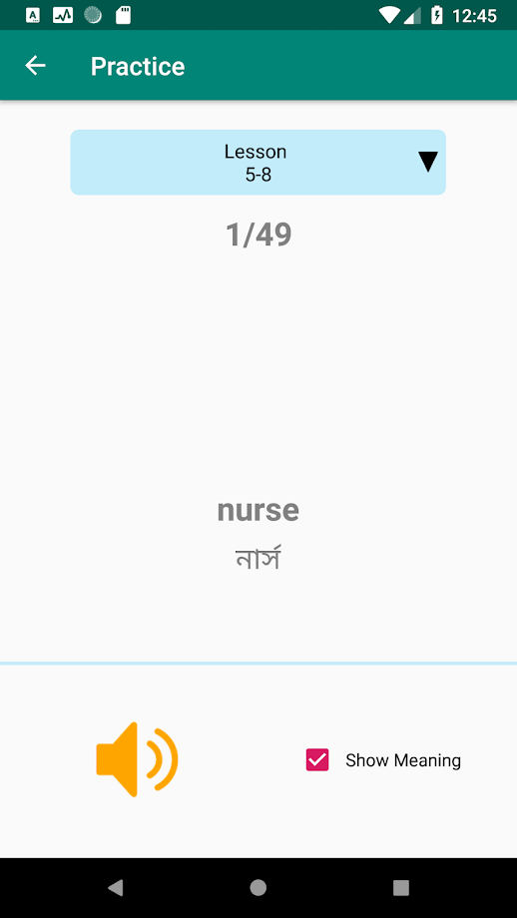

|  |  |  |
| --- | --- | --- |
| C:\Users\Zafor Iqbal\Desktop\Elogo\unnamed (1)\unnamed (4).png |  |  |

**Methodology:**

**The methodology involves preprocessing textual data to remove noise and standardize text, followed by the application of LDA to identify underlying topics. By transforming dense textual information into a collection of interpretable topics, readers can navigate through complex subject matter more efficiently. Moreover, the study proposes an interactive interface that integrates LDA-derived topics with the textbook, facilitating an immersive learning experience. This interface allows readers to explore content through relevant themes, thereby promoting active engagement and a deeper understanding of the material.**

To evaluate the effectiveness of this approach, a series of experiments are conducted using a diverse range of textbooks from various disciplines. The results demonstrate that LDA-based topic modeling significantly enhances content comprehension by providing concise summaries of the material. Readers can grasp the main ideas and connections between topics, aiding in retention and knowledge acquisition. Additionally, the interactive interface receives positive feedback for its user-friendly design and utility in assisting readers' navigation through the textbook.

1. Identify some popular mobile apps on the basis of google playstore review, number of user download in google play store.
2. List all the the techniques used in those apps, to determine which technique may affect and could be promising or accepted by students.
3. Develop questionnaire for teacher to explore the viewpoints of using mobile app based learning technology incorporation for learning English. Involve teachers in an interrogation session.
4. Enlist all the results, observe it through rigorous analysis.
5. We are expecting through this way we can find out most effective technique for teachers and students how the app can be built. We have anticipated a dummy version and build to demonstrate it infront of the survey participants so that we could get vauable feedback.

**Exploratory analysis of Textbook content**

Extensive analysis is conducted in this research to understand the context of the English Textbook. In this experiment we have used NLP based exploratory analysis to visualize the content. Here whole book is segregated into Lessons and we wanted to explore the important topics within the content. Similar topics words will remain together. Therefore assumptions is, it helps students to understands the words, sentences and context of the book.

* 1. First NLP’s data processing or data mining techniques are applied for meaningful token or feature extraction is conducted. All text converted to Lowercased and Normalized to ensure consistent pre-processing
     1. Data cleaning (unwanted characters Punctuation and Special Character Removed and stop words (such as "and," "the," "is," etc) are removed) spacy’s English word model and NLTK’s stopwords list are used together. Also Words less than two characters are removed such as: I, Hi, Oh etc. Hence, Noise is Removed and irrelevant characters, symbols, or data artifacts that have been introduced during data collection or scraping from pdf file to text file generation are separated. Hence, we found a cleaned corpus.
     2. Lemmatization (Root words are collected words to their dictionary form (lemma) is extracted) using NLTK’s WordNetLemmatizer package. Stemming Reduce words to their base or root form is not used since sometimes it changes the expression of actual words.
     3. Part-of-Speech Tagging: Spacy’s English model ‘en_core_web_sm’ is used to extract interested words (such as noun, verb, adjective) and excluded (CCONJ, AUX, DET, INTJ, PART etc which are Coordinating Conjunction, Auxiliary, Determinator, Interjection, Particle etc) thereby token is collected for only which are not punctuation, conjunction, symbol etc.

**Topic Modeling**

Latent Dirichlet Allocation (LDA) is a widely used topic modeling algorithm in natural language processing (NLP) that aims to discover latent topics within a collection of documents. Coherence is an important metric for evaluating the quality of topics generated by LDA or any other topic modeling algorithm.

In this research unsupervised machine learning technique coherence score used to discover number of similar latent topics in corpus (collection of Lesson documents). Coherence score estimates the number of meaningful topic determination, assess the quality of the topics produced by a topic modeling algorithm. Higher coherence values indicate that the topics are more coherent and representative of meaningful themes within the text data. Coherence is important because it ensures that the topics generated are statistically significant hence, we believe it helps students to do tasks like information retrieval, content recommendation, and text summarization etc.

To measure coherence in the context of LDA, following steps are used:

1. Trained LDA Model: During the training phase gensim’s MulticoreLDA model with four cpu worker thread, 20 iterations and n-gram corpus dictionary are assigned. After training LDA model assign topics to documents and estimate the distribution of words within each topic. These words represent the most salient terms associated with each topic.
2. Calculate Coherence: Calculate the coherence score for each topic by considering the pairwise similarity or relatedness of the top words within the topic. There are various coherence measures, such as Pointwise Mutual Information (PMI), Normalized Pointwise Mutual Information (NPMI), or others. Coherence ({'u_mass', 'c_v', 'c_uci', 'c_npmi'}) – Coherence measures values can be used where 'u_mass', 'c_v' are mostly used. For ‘u_mass’ corpus should be provided rather than data dictionary.
   1. C_v Coherence: C_v coherence uses a segmentation of the text into a fixed window size to compute the coherence of a topic. It considers the co-occurrence of words within a specific context window.
   2. Topic Coherence is based on pointwise mutual information (PMI) and can be represented as follows

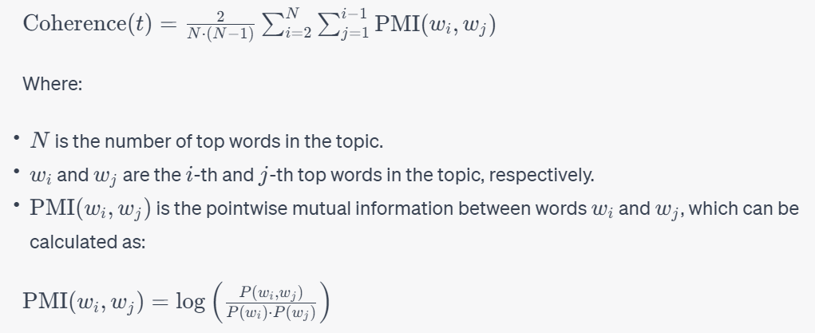

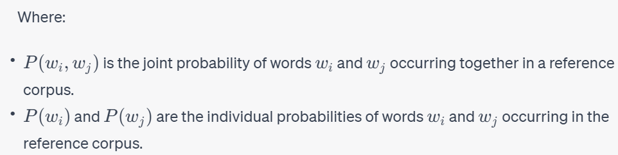

From the chart below we know that four to six topics are dominant in our provided corpus.

|  |  |
| --- | --- |
| Umass Coherence: C_umass returns negative values | CV Coherence: The coherence score for C_v ranges from 0 (complete incoherence) to 1 (complete coherence). |
|  |  |
| **Dominant topic and contribution**  In LDA models, each document is composed of multiple topics. But, typically some specific topics are dominant. The following experiment extracts this dominant topic for each sentence and shows the relative weight of the topic and the keywords. It estimated which document belongs predominantly to which topic. How frequently the words have appeared in the documents and the weights of each keyword in the same chart, words that occur in multiple topics and the ones whose relative frequency is more than the weight.  **Topic-Term Matrix Visualization and Inter-Topic Distance Map**  We trained a LDA model using library pyLDAvis, Gensim and Scikit-Learn parameters was provided four CPU core, 100 passes, 2o iterations and corpus’s token frequency’s enumerated data dictionary. pyLDAvis facilitates us to extract the necessary information from the trained LDA model, such as topic-term distributions and topic-document assignments.  The pyLDAvis library depict visualization and interpret the results by interactive web-based visualization. It combines various visualizations to understand the underlying topics, their relationships, and the distribution of words within each topic. pyLDAvis creates a scatter plot where each circle represents a topic. The distance between circles indicates the similarity between topics. pyLDAvis displays a bar chart histogram that represents the top terms contributing to that topic. This visualization helps you understand the most salient words associated with each topic. The visualization also includes a heatmap that shows the similarity between topics. Topics that are closer together in the map are more similar in terms of the distribution of words. This helps you understand the spread of word probabilities within a topic. | |
|  | |

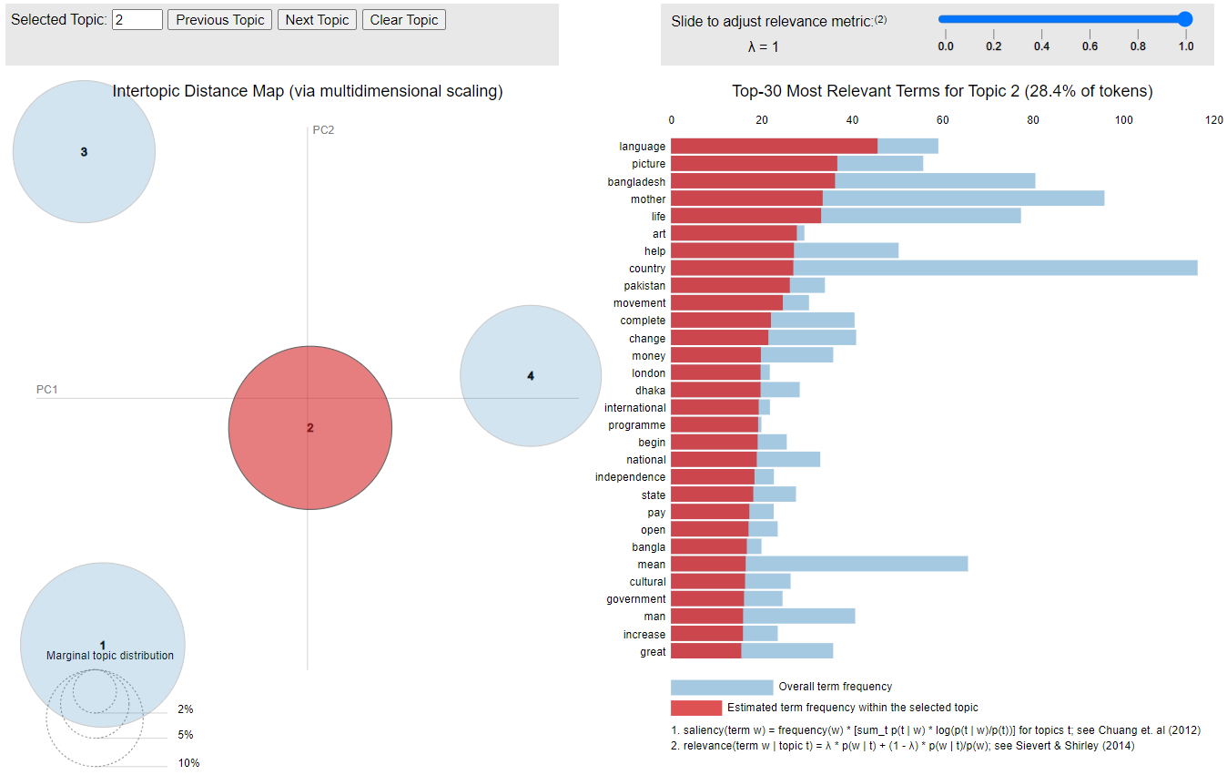

**Survey Planning**

The survey was conducted over a period of four weeks, with 50 High schools in Dhaka and Bogura district of Bangladesh. It encompasses only English subject areas Teachers who teaches in high schools from class six to class Ten and teaches regularly in the school. A questionnaire was distributed to teachers allowing us to gather a well-rounded perspective on the utilization of digital mobile-based learning. The questions focused on aspects such as frequency of technology usage among students for learning daily class tutorials, preferred learning activities related to specific apps, perceived advantages, and areas for improvement for a proposed solution.

**Survey Questionnaires**

* School or Organization Details (name, School or Organization Location (full address), School Type (Secondary/High School etc)
* School Infrastructural Condition, Number of Students Estimated, Number of Students in Each Class or Section)
* Teachers Details (Name, Phone Number, Year of Teaching Experience)
* Teachers' Social Sites address (e.g. FB, Linkedin, instagram etc)
* Graduation major was not English but currently teaching English subject
* English Teaching class or level
* Frequency of using digital content for teaching or digital medium for teaching and learning
* Internet or Mobile app to teach students or asked students to find solutions or learning materials from 16. Having experience of using mobile app for teaching and learning? Used internet or Mobile App such as (e.g. Youtube Tutorials)
* Do you think teacher will use a customized proposed mobile app for teaching
* Do you think students will use customized app for learning?
* Do you agree with the concept that mobile App and mobile based technology motivates students for learning English
* Do you agree with the concept that mobile App and mobile based technology App can replace guide book
* Do you think mobile app-based learning can improve English proficiency of students
* Any specific ideas How customized app can be improved specially for learning English for the context of Bangladesh
* Do you think Govt should promote these types of innovation for education sector

**Survey Results:**

We have done extensive analysis with the survey data collected. In our data collection highest priority is given for the secondary class student teachers who teach between 6-10th class about 46%. High school, KG college and KG High school. Details about the statistics are depicted in the following figure. Adjacent chart explains the percentage of teachers who teach in which class. Hence, from these two figures we can get a vivid image of collected dataset resources about the participating teachers.

|  |  |
| --- | --- |
| Forms response chart. Question title: 3. School Type. Number of responses: 50 responses. | Forms response chart. Question title: 13. English Teaching class or level. Number of responses: 50 responses. |

The infrastructure's overall quality and condition, which is generally above average, are shown in the following statistics. The majority of school owners are privately held 45%, yet there are some of variable quality. 32% of which are MPO institutes—non-government educational institutions that receive funding from the government nonetheless—and 22% of which are government institutes. There are quite a few students overall. Over 1000 students attend almost 40% of the institutions. A sizable number of pupils are present in each section and class. A significant percentage of classes—38%—have a size greater than 50. So, we can presume that the participating teachers have quite a bit of experience teaching a lot of children.

|  |  |
| --- | --- |
| Forms response chart. Question title: 4. School Owner. Number of responses: 50 responses. | Forms response chart. Question title: 5. School Infrastructural Condition. Number of responses: 50 responses. |
| Forms response chart. Question title: 6. Total Number of Students Estimated. Number of responses: 50 responses. | Forms response chart. Question title: 7. Number of Students in Each Class or Section. Number of responses: 50 responses. |

For the data privacy and security issues Teachers were reluctant to provide their social website address to the surveyor. Among 50 participants only 12 has, that means 24% attendees provided their social sites address to use them for research purpose.

The following graphs give an overview of the English teaching experiences of the teachers as well as the general consensus regarding the use of digital content and mobile apps in everyday teaching and learning. Almost 62% of teachers have been teaching for more than 8 to 10 years, and some of them have been teaching for decades in higher secondary education. 32% of teachers have three to eight years of experience, while just 6% are fresh to the profession. Around 83.7% of teachers The language of instruction during their graduation was English, and their major was also English. Very few teachers 13.3% graduation major is something other than English yet teaching English in secondary schools probably have sufficient English language proficiency.

|  |  |
| --- | --- |
| Forms response chart. Question title: 11. Experience of Teaching English (years). Number of responses: 50 responses. |  |
|  |  |

**Analysis Facts:**

More than half of teachers, or 58%, have no prior experience utilizing mobile apps or technology for teaching, but 90% of them agree, and more than 45% strongly agree, that it encourages pupils to engage actively in their learning. However, they (almost 60%) also hold the opinion that a notebook cannot be completely replaced, despite the fact that mobile apps may solve many problems and provide technological support for teaching and learning. Promisingly optimistic approximately 40%, although thinking that the notebook-based content memorizing learning method can be replaced, feel that mobile app-based learning can replace it permanently.

|  |  |  |
| --- | --- | --- |
| **Questions** | **yes** | **No** |
| Do you use digital content for teaching or digital medium for teaching and learning | 84% | 16% |
| Have you ever used Internet or Mobile app to teach students or asked students to find solutions or learning materials from internet or Mobile App such as (e.g. Youtube Tutorials) | 76% | 24% |
| Education during graduation was English and English was used for learning | 83.70% | 16.30% |
| **Customized mobile app for Learning and Teaching English** | | |
| Do you think teacher will use this mobile app for teaching | 92% | 8% |
| Do you think students will use this app for learning? | 80% | 20% |
| Do you think mobile app based learning can improve English proficiency of students | 86% | 14% |
| Do you think Govt should promote these types of innovation for education sector | 98% | 2% |

This study proposes the Englisher mobile app and presents it to the participating teachers to gather their insightful feedback. 92% of teachers reported that they would use this type of mobile app for teaching if it were made available after using the trial version of the offered customized Englisher app. Teachers anticipate that 80% of students will utilize this app during class. 86% of respondents believed it may help students' English proficiency, and 98% agreed that the government should support this kind of innovation in the education sector.

**24. How Englisher app can be improved:** The participants offer a variety of viewpoints for this question. Some of them mentioned that we could add additional vocabulary and involve more experience teachers who have greater experience in digital learning and teaching. Some participants, including teachers, made the suggestion that adding images, graphics would enhance the apps' usefulness and make them more visually appealing to users. More practice resources and exercise would be helpful. Practices for reading, writing, speaking, and listening are all possible. Another strategy is to provide antonym, synonym, and syllabus-related instances as well as audiovisual engagement with the app. Additionally, parental supervision may be used, and the app may benefit from parental comments to make improvements. The relevance of various terms used by participants is displayed in the word cloud below.

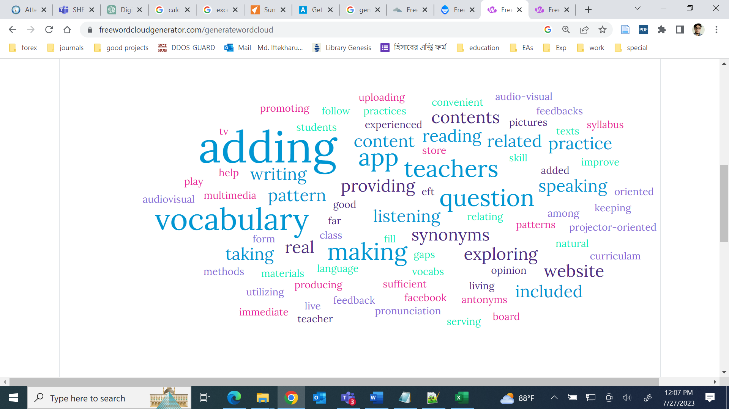

**25. How English learning can be improved using Mobile App:** Since the domain of both questions' question and response areas is the same, this follow-up question actually produced nearly identical answers. The app should be accessible to both students and teachers, various types of practice materials should be included, curriculum-based content and practice materials related to topics should be included in the app, related to topics would encourage users to use it diligently. These suggestions were among the many different ones that were discovered. The figure below illustrates the most prevalent words found in the responses.

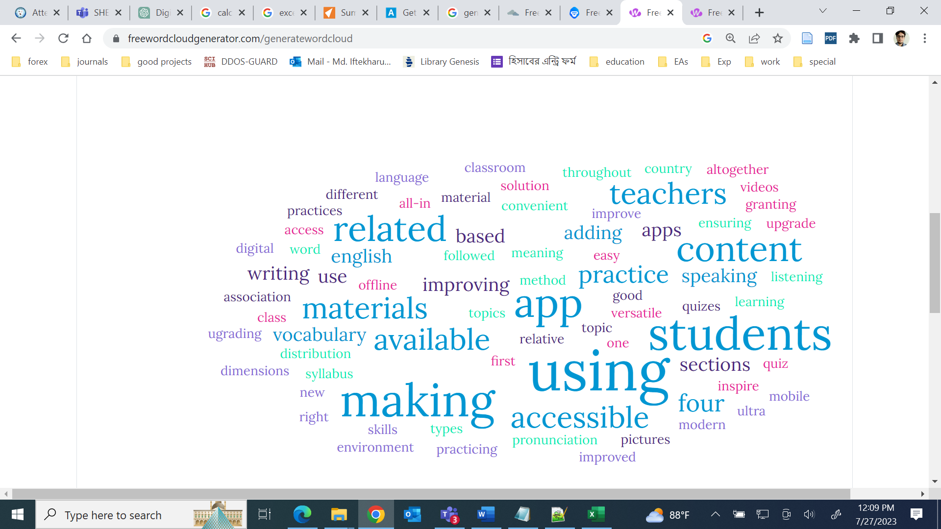

**Linguistic Inquiry and Word Count (LIWC)**

Additionally, we used Linguistic Inquiry and Word Count (LIWC) [31], [32] To ascertain the general sentiment of the responses given and interactions with the participants, the LIWC-22 analysis of the text sample was performed. When we used LIWC to analyze the responses, we discovered that the majority of respondents had a mix of optimism and skepticism regarding the use of mobile apps in teaching and learning. During the interrogation session, their tone was cordial and enticed thought process.

|  |  |  |  |  |
| --- | --- | --- | --- | --- |
|  | How this app can be improved | | How English learning can be improved using Mobile App | |
| Traditional LIWC Dimension | Answer Text | Average for | Answer Text | Average for |
|  |  | Formal Language |  | Formal Language |
| I-words (I, me, my) | 0 | 4.77 | 0 | 0.67 |
| Positive Tone | 2.54 | 3.96 | 3.91 | 2.33 |
| Negative Tone | 0 | 1.1 | 0 | 1.38 |
| Social Words | 2.54 | 6.87 | 5.65 | 6.54 |
| Cognitive Processes | 13.56 | 9.35 | 18.26 | 7.95 |
| Allure | 2.54 | 7.79 | 3.04 | 3.58 |
| Moralization | 0 | 0.2 | 0 | 0.3 |

Special Remarks:

For the data privacy and security issues Teachers were reluctant to provide their social website address to the surveyor. Among 50 participants only 12 have, that means 24% attendees provided their social sites address to use them for research purposes.

General Discussion and outcomes:

The study concludes apps seem effective as they provide a personal and learner-centered learning opportunity ubiquitously. However, apps need to be improved by including collaborative form of learning. Their recommendation is to make it specific. In our case we will make the app specific for NCTB Books only for particular class. This approach is also our goal considering NCTB Books.

The survey revealed that digital mobile-based learning significantly improved learning flexibility for the context of Bangladesh. Most of the participating teachers are enthusiastic about diverse Learning resources related to technology incorporating into pedagogy. Participants appreciated the diverse range of learning resources available through mobile devices, including interactive e-books, dictionary, educational apps, and multimedia content. Teachers admitted that available digital resources facilitated a deeper understanding of topics and catered to different learning styles, nurturing more engaging learning environment. This will positively impacted student motivation and overall engagement and hence boost overall learning. Some crucial suggestions were improve the graphics of the app so that it becomes interactive and parents involvement can be introduced. Based on the survey results, it is revealed the potential for digital mobile-based learning in school is immense. Government should take initiatives to incorporate it into course curriculum syllabus and could impose ordinance to adopt mobile app based learning teaching in the school.

Conclusion:

The school survey on digital mobile-based learning reaffirmed its potential to revolutionize education, promoting flexibility, engagement, and personalized learning experiences. In the survey questions, it was revealed teachers/instructors would find it acceptable and appreciated if textbook information were made available through a mobile app and presented in interactive format.

The study concludes apps seem effective as they provide a personal and learner-centered learning opportunity ubiquitously. Reveal to user as a complementary essential material to learn English Textbook quickly and effectively. However, apps need to be improved by including collaborative form of learning. Their recommendation is to make it specific.

By embracing this revolutionary approach, we aim to empower our students to become adaptive, tech-savvy learners, well-equipped to thrive in an increasingly digital world. The journey towards an empowered future of education has just begun, and we are committed to embracing the challenges and opportunities that lie ahead.

References

[1] S. Report, “Schools of 0,” *The Daily Star*, May 09, 2018. https://www.thedailystar.net/frontpage/schools-0-1573576 (accessed Jul. 28, 2023).

[2] W. B. Habib and T. S. Adhikary, “English, maths drag results down again,” *The Daily Star*, May 07, 2018. https://www.thedailystar.net/frontpage/ssc-examination-result-2018-bangladesh-english-maths-drag-results-down-again-1572613 (accessed Jul. 28, 2023).

[3] “Bangladesh Education Statistics 2021.” http://banbeis.portal.gov.bd/sites/default/files/files/banbeis.portal.gov.bd/npfblock/Bangladesh%20Education%20Statistics%202021_compressed-1-235.pdf (accessed Jul. 28, 2023).

[4] B. B. of E. I. and Statistics, *Bangladesh Educational Statistics 2016*, First Edition. Bangladesh Bureau of Educational Information and Statistics, 2017.

[5] J. Sandberg, M. Maris, and K. de Geus, “Mobile English learning: An evidence-based study with fifth graders,” *Comput. Educ.*, vol. 57, no. 1, pp. 1334–1347, Aug. 2011, doi: 10.1016/j.compedu.2011.01.015.

[6] S. Hu, K. Laxman, and K. Lee, “Exploring factors affecting academics’ adoption of emerging mobile technologies-an extended UTAUT perspective,” *Educ. Inf. Technol.*, vol. 25, no. 5, pp. 4615–4635, Sep. 2020, doi: 10.1007/s10639-020-10171-x.

[7] R. Shadiev, T. Liu, and W.-Y. Hwang, “Review of research on mobile-assisted language learning in familiar, authentic environments,” *Br. J. Educ. Technol.*, vol. 51, no. 3, pp. 709–720, 2020, doi: 10.1111/bjet.12839.

[8] S. F. Isamiddinovna, “Mobile Applications As A Modern Means Of Learning English,” in *2019 International Conference on Information Science and Communications Technologies (ICISCT)*, Nov. 2019, pp. 1–5. doi: 10.1109/ICISCT47635.2019.9011897.

[9] M. M. Elaish, L. Shuib, N. A. Ghani, and E. Yadegaridehkordi, “Mobile English Language Learning (MELL): a literature review,” *Educ. Rev.*, vol. 71, no. 2, pp. 257–276, Mar. 2019, doi: 10.1080/00131911.2017.1382445.

[10] B. Klimova, “Impact of Mobile Learning on Students’ Achievement Results,” *Educ. Sci.*, vol. 9, no. 2, Art. no. 2, Jun. 2019, doi: 10.3390/educsci9020090.

[11] M. L. Bernacki, J. A. Greene, and H. Crompton, “Mobile technology, learning, and achievement: Advances in understanding and measuring the role of mobile technology in education,” *Contemp. Educ. Psychol.*, vol. 60, p. 101827, Jan. 2020, doi: 10.1016/j.cedpsych.2019.101827.

[12] S. Criollo-C, A. Guerrero-Arias, Á. Jaramillo-Alcázar, and S. Luján-Mora, “Mobile Learning Technologies for Education: Benefits and Pending Issues,” *Appl. Sci.*, vol. 11, no. 9, Art. no. 9, Jan. 2021, doi: 10.3390/app11094111.

[13] X. Chen, “Evaluating Language-learning Mobile Apps for Second-language Learners,” *J. Educ. Technol. Dev. Exch.*, vol. 9, no. 2, Dec. 2016, doi: 10.18785/jetde.0902.03.

[14] V. N. Hoi, “Understanding higher education learners’ acceptance and use of mobile devices for language learning: A Rasch-based path modeling approach,” *Comput. Educ.*, vol. 146, p. 103761, Mar. 2020, doi: 10.1016/j.compedu.2019.103761.

[15] K. R. M. Rafiq, H. Hashim, and M. M. Yunus, “Sustaining Education with Mobile Learning for English for Specific Purposes (ESP): A Systematic Review (2012–2021),” *Sustainability*, vol. 13, no. 17, Art. no. 17, Jan. 2021, doi: 10.3390/su13179768.

[16] Z. Yu, W. Xu, and P. Sukjairungwattana, “Motivation, Learning Strategies, and Outcomes in Mobile English Language Learning,” *Asia-Pac. Educ. Res.*, vol. 32, no. 4, pp. 545–560, Aug. 2023, doi: 10.1007/s40299-022-00675-0.

[17] Z. Xu, Z. Chen, L. Eutsler, Z. Geng, and A. Kogut, “A scoping review of digital game-based technology on English language learning,” *Educ. Technol. Res. Dev.*, vol. 68, no. 3, pp. 877–904, Jun. 2020, doi: 10.1007/s11423-019-09702-2.

[18] Y. Hao, K. S. Lee, S.-T. Chen, and S. C. Sim, “An evaluative study of a mobile application for middle school students struggling with English vocabulary learning,” *Comput. Hum. Behav.*, vol. 95, pp. 208–216, Jun. 2019, doi: 10.1016/j.chb.2018.10.013.

[19] B. Klímová and A. Berger, “Evaluation of the Use of Mobile Application in Learning English Vocabulary and Phrases – A Case Study,” in *Emerging Technologies for Education*, T. Hao, W. Chen, H. Xie, W. Nadee, and R. Lau, Eds., in Lecture Notes in Computer Science. Cham: Springer International Publishing, 2018, pp. 3–11. doi: 10.1007/978-3-030-03580-8_1.

[20] C.-H. Chen and C.-C. Tsai, “In-service teachers’ conceptions of mobile technology-integrated instruction: Tendency towards student-centered learning,” *Comput. Educ.*, vol. 170, p. 104224, Sep. 2021, doi: 10.1016/j.compedu.2021.104224.

[21] I. García-Martínez, J. M. Fernández-Batanero, D. Cobos Sanchiz, and A. Luque de la Rosa, “Using Mobile Devices for Improving Learning Outcomes and Teachers’ Professionalization,” *Sustainability*, vol. 11, no. 24, Art. no. 24, Jan. 2019, doi: 10.3390/su11246917.

[22] H. Oz, “An Investigation of Preservice English Teachers’ Perceptions of Mobile Assisted Language Learning,” *Engl. Lang. Teach.*, vol. 8, no. 2, pp. 22–34, 2015.

[23] J. Kacetl and B. Klímová, “Use of Smartphone Applications in English Language Learning—A Challenge for Foreign Language Education,” *Educ. Sci.*, vol. 9, no. 3, Art. no. 3, Sep. 2019, doi: 10.3390/educsci9030179.

[24] Z. Jie and Y. Sunze, “Investigating pedagogical challenges of mobile technology to English teaching,” *Interact. Learn. Environ.*, vol. 31, no. 5, pp. 2767–2779, Jul. 2023, doi: 10.1080/10494820.2021.1903933.

[25] R. Metruk, “The Use of Smartphone English Language Learning Apps in the Process of Learning English: Slovak EFL Students’ Perspectives,” *Sustainability*, vol. 13, no. 15, Art. no. 15, Jan. 2021, doi: 10.3390/su13158205.

[26] M. Shortt, S. Tilak, I. Kuznetcova, B. Martens, and B. Akinkuolie, “Gamification in mobile-assisted language learning: a systematic review of Duolingo literature from public release of 2012 to early 2020,” *Comput. Assist. Lang. Learn.*, vol. 36, no. 3, pp. 517–554, Mar. 2023, doi: 10.1080/09588221.2021.1933540.

[27] P. Poláková and B. Klímová, “Mobile Technology and Generation Z in the English Language Classroom—A Preliminary Study,” *Educ. Sci.*, vol. 9, no. 3, Art. no. 3, Sep. 2019, doi: 10.3390/educsci9030203.

[28] R. Kaliisa, E. Palmer, and J. Miller, “Mobile learning in higher education: A comparative analysis of developed and developing country contexts,” *Br. J. Educ. Technol.*, vol. 50, no. 2, pp. 546–561, 2019, doi: 10.1111/bjet.12583.

[29] A. Kao and S. R. Poteet, *Natural Language Processing and Text Mining*. Springer Science & Business Media, 2007.

[30] P. M. McCarthy and C. Boonthum-Denecke, Eds., *Applied Natural Language Processing: Identification, Investigation and Resolution*. IGI Global, 2012. doi: 10.4018/978-1-60960-741-8.

[31] “Welcome to LIWC-22.” https://www.liwc.app/ (accessed May 06, 2023).

[32] “The Psychological Meaning of Words: LIWC and Computerized Text Analysis Methods - Yla R. Tausczik, James W. Pennebaker, 2010.” https://journals.sagepub.com/doi/abs/10.1177/0261927x09351676 (accessed Jul. 28, 2023).